## Name: Owais Ali Khan, Roll: 21K-3298, Section:3-F

COAL Theory Assignment 2:

# Question 1:

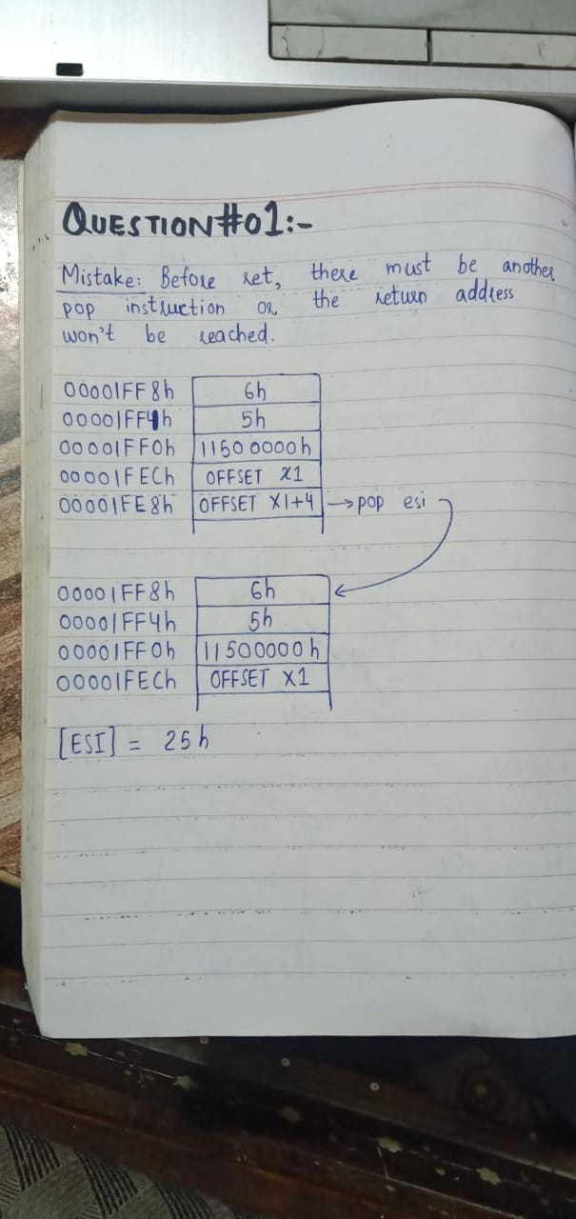

# Question 2:

ZF = 0,

ZF = 1

# Question 3:

INCLUDE Irvine32.inc

.data

source SDWORD 40d,-90d,-67d,98d,78d,-45d,0d,32d

target SDWORD 8 DUP(0)

count = 0

.code

main PROC

mov eax, 8 ; parameter 1

mov esi, 0

call saveArray

exit

main ENDP

saveArray PROC USES eax esi

mov ecx, eax

mov ebx, 0

mov edi, count

L1:

mov edx, source[esi]

cmp edx, 0

jg pos

jmp skip

pos:

mov target[ebx], edx

add ebx, TYPE target

add esi, TYPE target

add edi, 1

jmp ENDD

skip:

add esi, TYPE source

ENDD:

loop l1

mov ecx, edi

mov esi, 0

L2:

mov eax, target[esi]

call WriteDec

add esi, TYPE target

call Crlf

loop L2

ret

saveArray ENDP

END main

# Question 4:

INCLUDE Irvine32.inc

.data

N SDWORD 3

A SDWORD 5

B SDWORD 2

msg BYTE "Value of n = ", 0

.code

main PROC

mov eax, N

mov ebx, A

mov edx, B

WHILE:

cmp eax, 0

jbe ENDWHILE

cmp eax, 3

jne COND

jmp ELSE

COND:

cmp eax, ebx

jl YES

cmp eax, edx

jg YES

jmp ELSE

YES:

sub eax, 2

jmp WHILE

ELSE:

sub eax, 1

jmp WHILE

ENDWHILE:

mov edx, OFFSET msg

call WriteString

Call WriteDec

exit

main ENDP

END main

# Question 5:

INCLUDE Irvine32.inc

.data

N DWORD 3

A DWORD 5

B DWORD 2

Msg BYTE "Enter a number: ",0

.code

main PROC

mov edx, OFFSET Msg

call WriteString

Call ReadDec

cmp al, 1

je ODD

cmp al, 3

je ODD

cmp al, 2

je EVEN

cmp al, 4

je EVEN

ODD:

mov eax, “o”

call WriteChar

jmp ENDD

EVEN:

mov eax, “e”

call WriteChar

ENDD:

exit

main ENDP

END main

# Question 6:

INCLUDE Irvine32.inc

INCLUDE macros.inc

.data

A = 100

B = 200

C = 0

.code

main PROC

mov eax, A

mov ebx, B

mov edx, C

mov ecx, 5

L1:

cmp ecx, 0

jb ExitL1

add ebx, eax

mWrite "b = "

push ecx

mov ecx, 5

push eax

mov eax, ebx

Call WriteDec

pop eax

Call crlf

L2:

cmp ecx, 0

jb ExitL2

sub eax, 1

add edx, 10

loop L2

ExitL2:

mWrite "a = "

Call WriteDec

Call crlf

push eax

mov eax, edx

mWrite "c = "

Call WriteDec

Call crlf

pop eax

pop ecx

loop L1

ExitL1:

exit

main ENDP

END main

# Question 7:

INCLUDE Irvine32.inc

.data

loopCounter DWORD 8

.code

main PROC

mov ecx, Counter

L1:

push ecx

mov eax, loopCounter

L2:

call WriteDec

sub eax, 1

loop L2

call Crlf

pop ecx

loop L1

exit

main ENDP

END main

# Question 8:

INCLUDE Irvine32.inc

.data

Msg1 BYTE “Odd parity”, 0

Msg2 BYTE “Even parity”, 0

.code

main PROC

mov al, 01110101b

add al, 0

call DumpRegs

jp EVEN

mov edx, OFFSET Msg1

call WriteString

jmp ENDD

EVEN:

mov edx, OFFSET Msg2

call WriteString

ENDD:

exit

main ENDP

END main